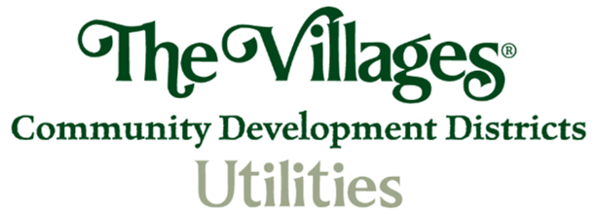

**Meter Replacement Frequently Asked Questions:**

**Q. What is the Meter Replacement Program?** The Villages Community Development Districts is moving ahead with its Advanced Metering Initiative for all Water Meters (Residential & Commercial / Potable & Irrigation). We are implementing Automated Meter Reading (AMR) technology, which is a method of using communication technology to read meters without having to access the meter, which is physically located in a meter box in the ground. The District has chosen a system that uses a small radio transmitter that is connected to the water meter, which is known as the “end point”. The radio device collects a reading from the meter and transmits the reading to a collection/receiver device located in a vehicle that’s being driven through the community. Village Center Community Development District, North Sumter County Utility Dependent District and the Wildwood Utility Dependent District have all approved the selection and implementation AMR technology, based on the Automated Meter Reading Pilot Study (2024) conduct by District Utilities, as supported by their Multi-Year Capital Improvement Plans.

**Q. What is AMR?** AMR is a standard for utilities around the country. AMR meters allow for more accurate and faster collection of water usage readings than the current manual method, improve safety conditions for District staff as well as our Operations and Maintenance Contractor, Jacobs. Currently, the meter readers must “touch read” at the physical meter box or open a meter box to obtain a reading. Introducing AMR as the standard for The Villages® community is one of the ways to better serve our customers. AMR is a method of using advanced communications technology to read meters remotely. It reduces human errors and ensures that customers receive an accurate bill each month. Utilities use automated reads for billing purposes, however, the dials will still be visible on the meter, so you can read your own meter and confirm that our reading is accurate. AMR increases privacy and convenience for our customers as it eliminates the need for a meter reader to enter our customers’ property each month to read the meter. Because AMR reduces costs and identifies potential theft, it also helps us keep rates as low as possible.

**Q. When will this Project Start?** Installation is expected to begin in November 2024 and will be completed in a phased approach over the following four (4) years, with replacement timing to be determined based on the individual utility, age, and brand of meters to be replaced. The District-wide AMR program will replace the nearly 140,000 existing residential and commercial meters. AMR “drive by” radio transmission operates in compliance with Federal Communications Commission regulations to avoid interference with other electronic devices. AMR meters come pretested along with test results directly from the manufacturer. The radio device is tested for accuracy during the meter collection process regularly. Due to the high level of detail through the setup and installation process, there is no possibility of “accidentally” reading a neighbor’s meter with an AMR system. Each radio frequency device has a unique identification number, which is transmitted along with the meter reading. The unique number is compared to each account record to ensure a match. Under our Neptune AMR technology solution, nearly all commercial and residential customers will receive a brand-new water meter and register, as well as a brand-new endpoint. This ensures accuracy of the meter and standardization of the specific technology across The Villages® community, with every residential meter being the exact same make and model versus the current system consisting of seven different brands and numerous models.

**Q. When will I be impacted and how will I be notified?** Residents will receive a post card in the mail in advance of installation advising them of the approximate time frame that contractor National Metering Services, Inc. will be working in their neighborhood. Since water meters are located outside of the home in a right of way, residents will not need to be home for the replacement meter installation. There will be very minimal interruptions to water service during the meter replacement process. All meters will be replaced to upgrade the meter to one capable of communicating with the AMR equipment, and as an extension of an existing program to replace aging meters as they reach the end of their life cycle. NMS will place a “door knocker” on the residents home indicating that the meter replacement upgrade has been completed.

**Q. Why is the District replacing and upgrading my Water Meter?** District-Owned Utilities approved the replacement of manual-read water meters with advanced meter reading technology in August 2024, following years of consideration, analysis, and planning. The new meters will more accurately capture actual water usage, so some customers may see a difference in consumption and their subsequent bill amount, due to the improved performance of the new meter. The District selected Neptune AMR Technology, which will automate the District’s current manual meter reading process. With Advanced Metering, the District will be able to improve service and operational efficiency.

**Q. How does the new system work?** The Automated Meter Reading (AMR) system is made up of several “smart” components that communicate using radio frequency technology. The meters and communication system are regulated to meet all federal communications, safety standards and codes. There is no personal identifying information captured by the smart point or transmitted by the meter.

**Q. Do I have to pay for my new meter?** No, the District is covering the costs of the meters and their installation. The District has prepared for the cost of this project as part of its 5 Year Capital Improvement Planning Process.

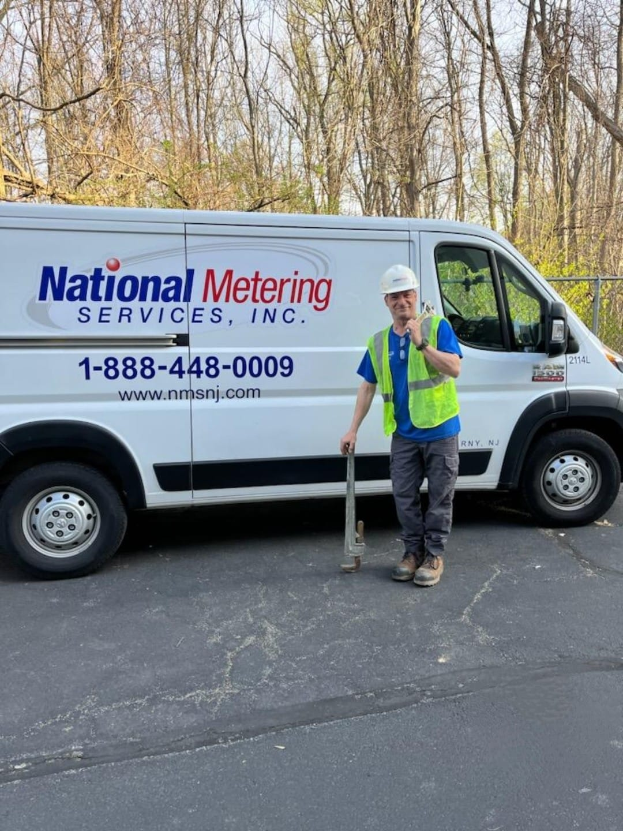**Q. About the Installation Project Who is doing the actual work?** The installation project is being managed for the District by National Metering Services, Inc, out of their Clermont, Florida location. National Metering Services is an advanced metering consulting firm, specializing in AMR and AMI evaluation, implementation, and optimization. National Metering Services is responsible for the day-to-day management of the installation and will handle vendor coordination on behalf of the District. National Metering Services will have a project manager onsite and will be responsible for providing and installing the meters. Installers working on the project will carry proper badge identification and have successfully completed a background check. The installers will not need to enter residential property, nor will they be asking for any form of payment from customers. National Metering Services (NMS) installers are required to always wear uniforms and display identification badges. Their vehicles are also marked with the company name.

**Q. How long will I be without water during installation?** While replacement times will vary, replacing a meter should take no longer than 15 minutes for residential meters, during which the water will be shut-off for a portion of that time. The installation crew will make every effort to keep the interruption to your service to a minimum. Commercial and industrial customers will be contacted in advance to schedule installation to minimize the disruption to their business.

**Q. How do I know when my meter will be replaced?** The District website at <https://www.districtgov.org/services/utilities/water/> will have the latest meter replacement schedule, however you will also receive a post card from National Metering Services approximately two weeks before your scheduled meter replacement date.

**Q. What should I do in preparation for the meter replacement?** Ensure that your meter box is fully accessible and clear from any trees, shrubbery, plants and sod. Ensure that the entire box top is visible, and the lid is easily accessible. National Metering Services will cut back vegetation, if required, to access the meter box. If the meter box is not readily accessible, National Metering Services nor the District are responsible for any damages to landscaping or property that must be removed, trimmed, cut or otherwise damages to allow for access to the meter box. There will be no need to boil water after installation, but you may experience temporary air bubbles or discolored water. Please briefly run cold water to clear it up.

**Q. Who do I contact with questions or problems relating to my meter replacement?** The installation team at National Metering Services has a toll-free customer contact line that is staffed 24/7. Please call them at 1-800-448-0009 with questions or concerns regarding your meter replacement.

**Q. Who do I contact if there is a leak at or near the Meter Box after installation?** The installation team at National Metering Services has a toll-free customer contact line that is staffed 24/7. Please call them at 1-800-448-0009 regarding any leaks. National Metering Services guarantees their work to be leak-free for 30 days after installation.

**Q. Will the transmitter radio frequency interfere with my television or phones?** No, the radio transmission operates in compliance with FCC regulations to avoid interference with other electronic devices.

**Q. Does Automated Meter Reading (AMR) have any other benefits?** Yes. AMR improves accuracy. It will detect possible leaks faster and may allow us to notify you of problems before they become serious, and costly. It also eliminates the need for manually reading meters, except for periodical maintenance or replacement of system components, when needed. This allows the District to be more efficient and save money by preventing recording errors and minimizing wear and tear on the District’s automobile fleet.

**Q. Have the new meters been tested for accuracy?** Yes, the all-new meters have been tested and guaranteed accurate by the manufacturer, Neptune, in compliance with American Water Works Association (AWWA) accuracy standards.

**Q. Will my water bill increase?** Your new meter measures the amount of water used during the billing period by measuring how much water passes through the meter, which is the same measurement process as your old water meter. New meters may register lower flows that your older meter might not have been able to capture, which means that although your bill may increase, your meter is now accurately recording your water consumption.

**Q. Could I have a leak that is causing extra water usage?** If you have an unexplained spike in your water usage or show continuous water flow, it may be an indication of a leak.

**Q. Who can I talk to about my water bill?** If you have questions regarding your water bill, please contact Utilities Customer Service at 352-750-0000 or utilities@districtgov.org.